**2nd ICOS-PH 2025 POSTER PARTICIPANT GUIDELINES**

# All poster presentations at The 2nd ICOS-PH 2025 must follow these rules.

# **Language**. Posters must be written and presented in academic British or American English. Choose one consistently throughout the poster.

# **Dimensions and Orientation**. Posters must be printed on a single page in X-banner format, with dimensions of 60 cm (width) × 160 cm (height) in portrait orientation.

# **Content Structure.** Include only key information from each of the following sections:

# Title

# Authors

# Affiliations

# Background

# Aims/Objectives

# Methodology

# Tables/Pictures Area

# Findings

# Conclusion

# References

# **Header Layout**. The top section of the poster should display the title, the names of authors, and affiliations. It is preferable to use no more than two different font types to ensure clarity and consistency throughout the poster.

# **Logo Placement**. The 2ndICOS-PH logo must be placed in the top left corner of the poster, and the Universitas Hasanuddin logo should be positioned in the top right corner.

# **Fonts**.Use no more than two complementary font types to maintain clarity and consistency.

# **Spacing**. Ensure ample space between sentences, paragraphs, and visuals to enhance readability.

# **Color Scheme**. Apply contrasting and harmonious colors for background, fonts, and graphical elements. Avoid using overly bright or low-contrast combinations.

# **Typography**. Use clear, simple fonts. Bold formatting can be used strategically for titles and headings. Avoid decorative or script fonts.

# **Visuals (Figures, Tables, Images)**. Each visual element should clearly convey a single main idea using straightforward labels, avoiding cluttered or overly complex visuals. Charts, graphs, and images must be presented in high resolution (minimum 300 dpi) to effectively illustrate the data.

# **Text and Image Readability**. All text and images must be easily readable from a minimum of 1 meter away.

# **Oral Summary**. Poster presenters must deliver a 3-5 minute verbal presentation explaining their research to conference participants.

# Note :

# It should be noted that all poster materials must be prepared in advance and brought to the conference by the presenter. The conference organizers will not provide facilities for printing or creating posters on-site. The printed poster must be put in the poster area since H-1 conference from … 2025 no later than … Central Indonesia Time until … at …. Central Indonesia Time.

**POSTER SIZE DESIGN**

**60 cm**

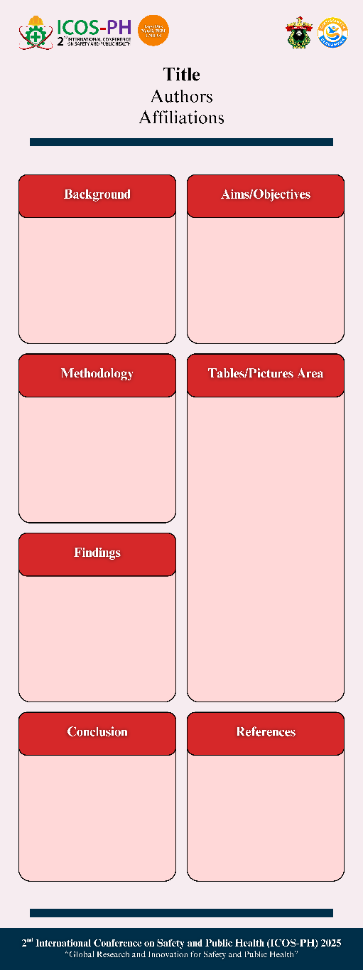

**160 cm**

**POSTER ASSESSMENT CRITERIA**

|  |  |  |
| --- | --- | --- |
| **CRITERIA** | **ASSESSMENT WEIGHT** | **POINTS** |
| The relevance of the poster to the theme | 30% | … X 30% |
| Text and image composition | 20% | … X 20% |
| Communicative, informative, educational and provocative | 30% | … X 30% |
| Usefulness of Information | 20% | … X 20% |
| **TOTAL** | 100% |  |